Java E
Formulario original: https://docs.google.com/forms/d/e/1FAIpQLSe5tBJnebiCm9qi_R0lOHV_K8sQLVKImWe5kM0L6OJszEsuIQ/viewform
Enlazado desde: Exámenes de apoyo/LINKS.docx
Preguntas y opciones extraídas del formulario público el 24-sep-2026 (solo lectura; no se respondió ni se envió). El formulario no expone la clave de respuestas, así que este documento no marca la opción correcta.
Prueba diagnóstica de Java
Pregunta 1 (selección múltiple)
What two keywords may precede the word 'class' in a class declaration?
a) Synchronized
b) Volatile
c) Static
d) Local
e) Public

Pregunta 2 (opción única)
What is the result if you try to compile Truthy.java and then run it with assertionsenabled?
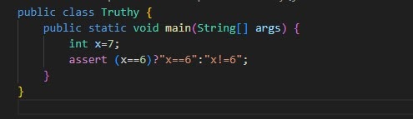
a) Truthy.java does NOT compile.
b) Truthy.java compiles and the output is x != 6
c) Truthy.java compiles and an AssertionError is thrown with no additional output
d) Truthy.java compiles and an AssertionError is thrown with x != 6 as additional output

Pregunta 3 (opción única)
What values of x, y, z will produce the following result? 1234 1234 1234 --- 1234 ---
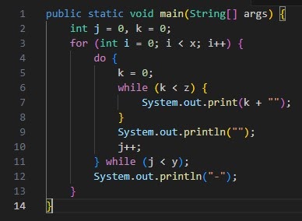
a) - int x = 2, y = 3, z = 4;
b) - int x = 4, y = 3, z = 2;
c) - int x = 3, y = 2, z = 3;
d) - int x = 4, y = 2, z= 3;
e) - int x = 2, y = 3, z = 3;

Pregunta 4 (opción única)
What is the result?
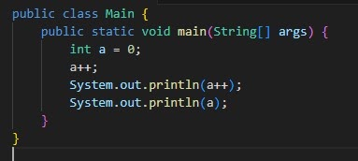
a) 0 1
b) 1 2
c) 1 1
d) 2 2

Pregunta 5 (opción única)
In Java the difference between throws and throw Is:
a) Throws throws an exception and throw indicates the type of exception that the method.
b) Throws is used in methods and throw in constructors.
c) Throws indicates the type of exception that the method does not handle and throw an exception.

Pregunta 6 (opción única)
What is the result?
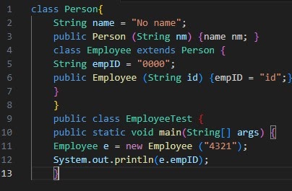
a) 4321
b) An exception is thrown at runtime.
c) 0000
d) Compilation fails because of an error in line 9

Pregunta 7 (opción única)
What is the result value of w?
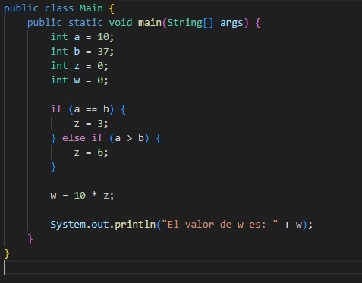
a) 30
b) 60
c) 0

Pregunta 8 (opción única)
What is the result?
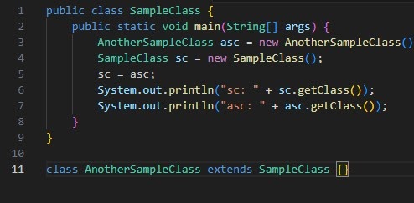
a) sc: class.SampleClass asc: class.AnotherSampleClass
b) sc: class.Object asc: class.AnotherSampleClass
c) sc: class.AnotherSampleClass asc: class.SampleClass
d) sc: class.AnotherSampleClass asc: class.AnotherSampleClass

Pregunta 9 (opción única)
What is the result?
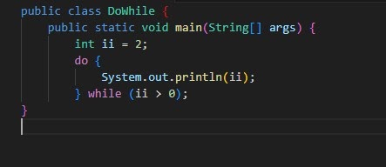
a) 1 0
b) 2 1 2
c) Compilation fails
d) An infinite loop

Pregunta 10 (opción única)
What value should replace kk in the comment to cause jj = 5 to be output?
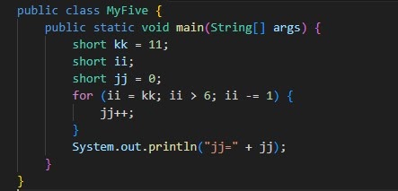
a) -1
b) 1
c) 5
d) 8
e) 11

Pregunta 11 (opción única)
What is a static block of code in Java?
a) A block of code within a class that runs whenever the class is load on the JVM.
b) A block of code inside a class that runs when that class first loaded in JVM
c) A block of code within a class that always runs before the builder.

Pregunta 12 (opción única)
What is the result?
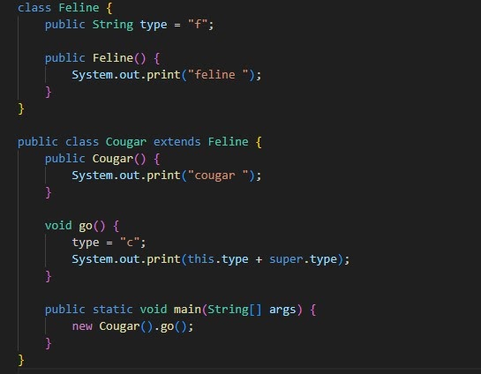
a) Cougar c f
b) Compilation fails
c) Feline cougar c c
d) Feline cougar c f

Pregunta 13 (opción única)
What is the result?
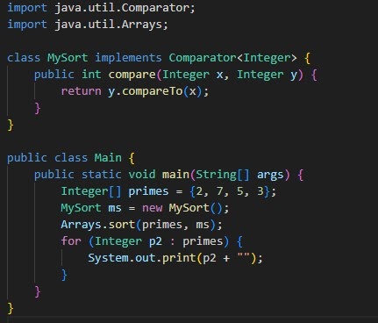
a) Compilation fails
b) 2 7 5 3
c) 2 3 5 7
d) 7 5 3 2

Pregunta 14 (opción única)
The SINGLETON pattern allows:
a) Have a single instance of a class and this instance cannot be used by other classes.
b) Having a single instance of a class, while allowing all classes have access to that instance.
c) Having a single instance of a class that can only be accessed by the first method that calls it.

Pregunta 15 (opción única)
What will make this code compile and run?
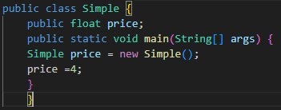
a) Change line 7 to the following: float price = new Simple ();
b) Change line 7 to the following: price = 4f;
c) Change line 3 to the following: public int price;
d) Change line 7 to the following: int price = new Simple();
e) Change line 7 to the following: price.price = 4;

Pregunta 16 (opción única)
What is the result if the integer value is 33?
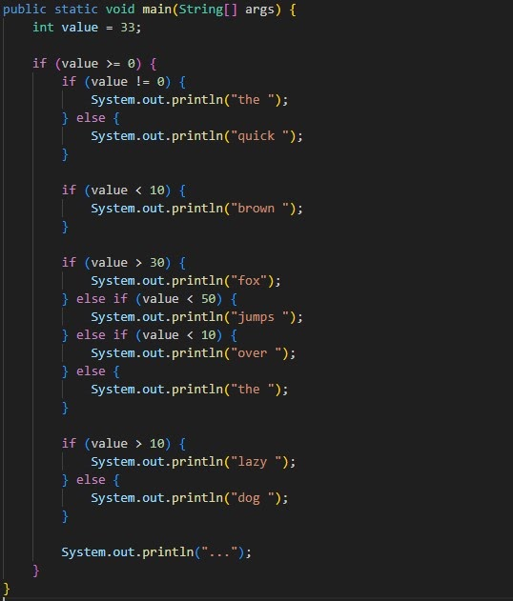
a) The fox lazy...
b) The fox jump lazy...
c) Quick fox over lazy...
d) Quick fox the...

Pregunta 17 (opción única)
In the Java collections framework a Set Is:
a) An ordered collection that can contain duplicate elements.
b) A collection that cannot contain duplicate elements.
c) An object that maps value key sets and cannot contain values Duplicates.

Pregunta 18 (opción única)
What is the result?
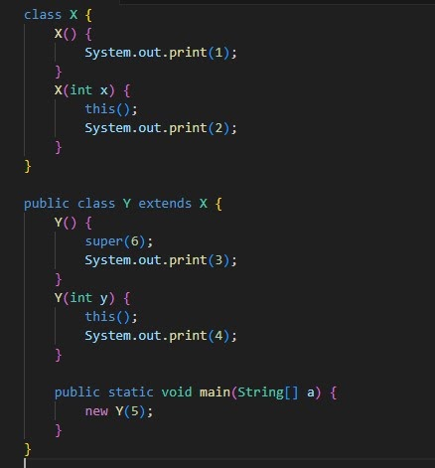
a) 1213
b) 2143
c) 4321
d) 134
e) 13
f) 2134

Pregunta 19 (opción única)
Which two actions, used independently, will permit this class to compile?
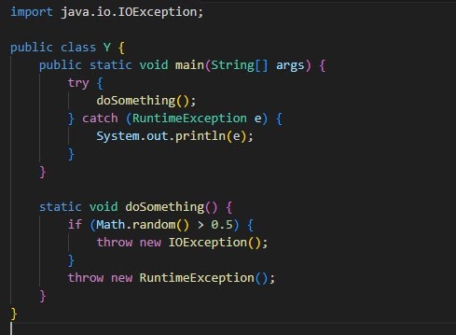
a) Adding throws IOException to the main() method signature and to the dosomething() method
b) Adding throws IOException to the doSoomething() method signature.
c) Adding throws IOException to the main() method signature
d) Adding throws IOException to the dosomething() method signature and changing the catch
e) Adding throws IOException to the main() method ....IOException

Pregunta 20 (selección múltiple)
Which two statements are true?
a) An interface CANNOT be extended by another interface
b) An abstract class CANNOT be extended by an abstract class
c) An abstract class can be extended by a concrete class.
d) An abstract class can implement an interface
e) An abstract class can be extended by an interface
f) An interface can be extended by an abstract class

Pregunta 21 (opción única)
The pom.xml file is the configuration file For:
a) Maven
b) Gradle
c) Ant

Pregunta 22 (opción única)
What is the result?
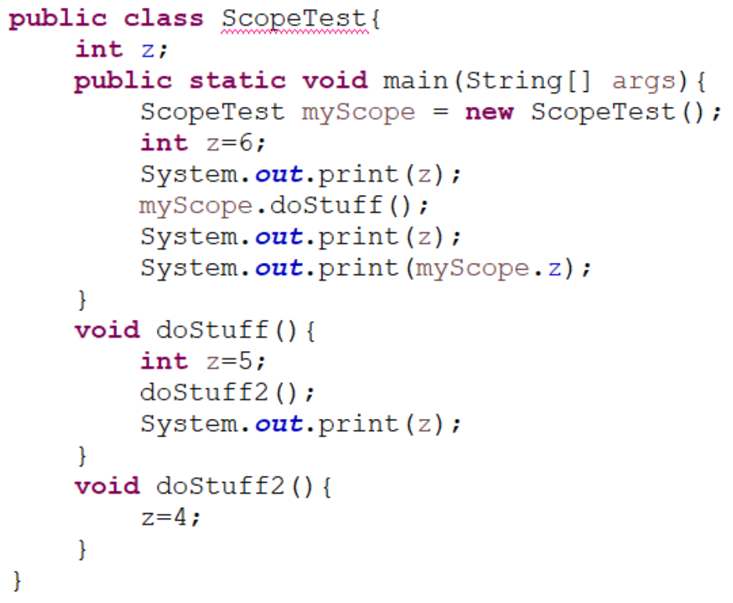
a) 6565
b) 6504
c) 6550
d) 6560

Pregunta 23 (opción única)
A method is declared to take three arguments. A program calls this method andpasses only two arguments.What is the result?
a) An exception occurs when the method attempts to access the third argument.
b) The third argument is given the value zero.
c) Compilation fails
d) The third argument is given the value null.
e) The third argument is given the appropriate false value for its declared type.
f) The third argument is given the value void.

Pregunta 24 (opción única)
Which code fragment is illegal?
a) Class Base1 { abstract class Abs1 { } }
b) Abstract class Abs2 { void doit() { } }
c) class Base2 { abstract class Abs3 extends Base2 { } }
d) class Base3 { abstract int var1 = 89; }

